Asia-China-Coin-Knife Money , Straight Knives -Unknown-Model Money

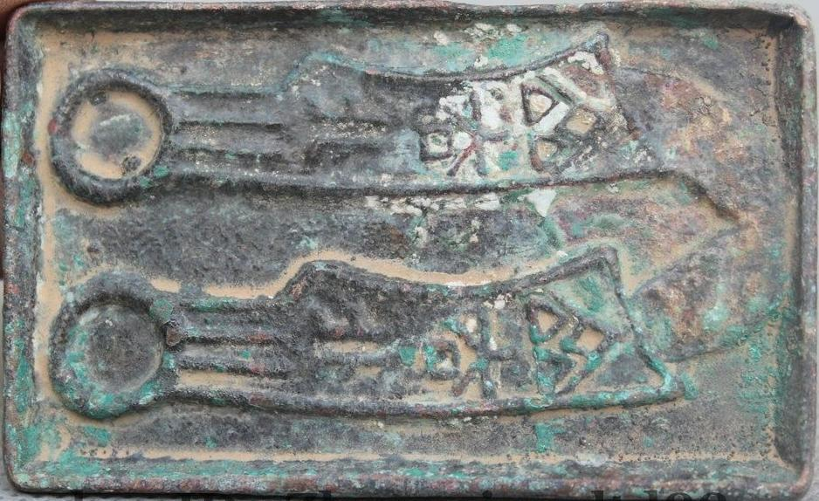

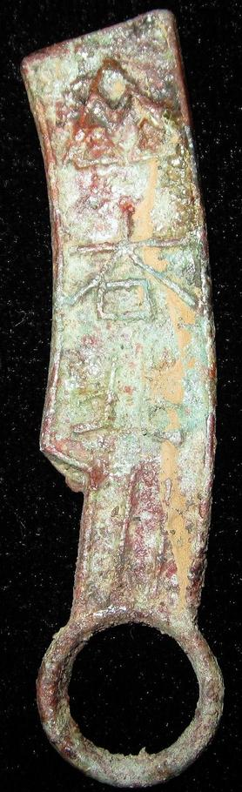 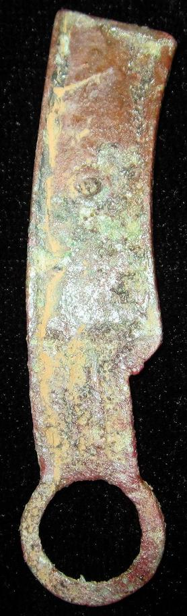

length 6 cm. / 2.36 in., width 1.3 cm. / 0.51 in.

齐法化,The famous "QiFaHua"Falchion-shape coin."齐"means the QI Nation in the Warring States Period."法",legal."化"also"货",Coin.So,The "齐法化"means legal tender of the Qi Nation.It should be made and used in the Qi Nation(About 284BC-279BC),Warring States period.

This collection is a very rare Bronze Falchion-shape Coin.

SHAPE \* MERGEFORMAT 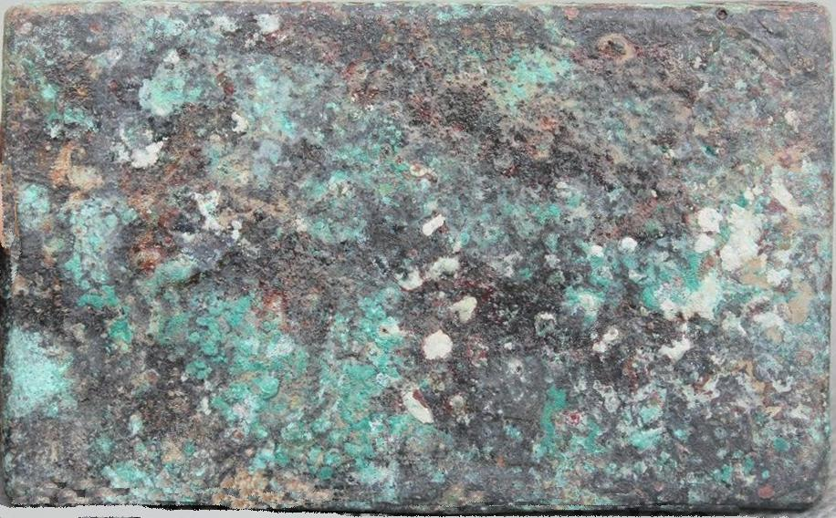

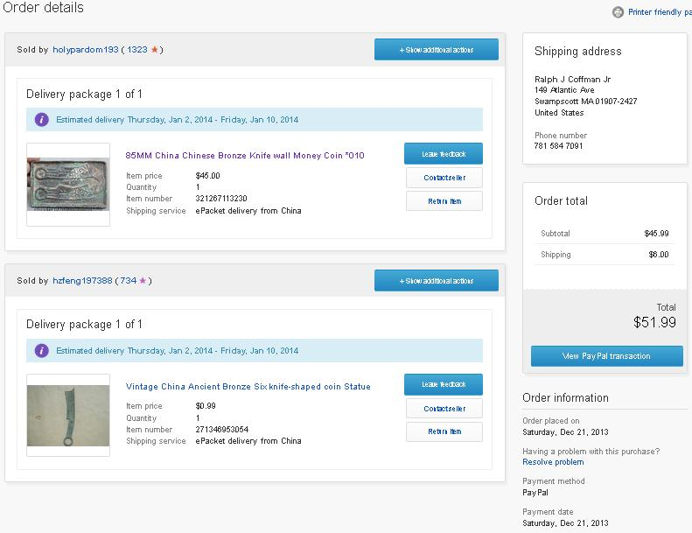

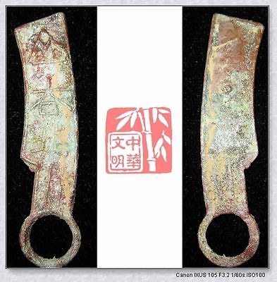

[WarringStatesPeriod QI NATION LEGAL TENDER MONEY BRONZE FALCHION COIN齐法化SealRing](http://www.ebay.com/itm/251407861234)

Item price

$9.99

Quantity

1

Item number

251407861234

Shipping service

Economy Shipping from outside US

[Leave feedback](http://feedback.ebay.com/ws/eBayISAPI.dll?LeaveFeedbackShow&useridfrom=802-867&useridto=bcculture&item=251407861234&transactid=0) [Contact seller](http://contact.ebay.com/ws/eBayISAPI.dll?FindAnswers&frm=3998&iid=251407861234&redirect=0&requested=bcculture) [Return item](http://return.ebay.com/ws/eBayISAPI.dll?ResolveReturn&eventName=viewSelectedItem&TransactionId=0&ItemId=251407861234)